Adaptive EKF-Based Navigation for Mars Entry, Descent, and Landing Under Simulated IMU Degradation and Dust-Dependent TRN Uncertainty

Author: Keila Fortes

Abstract
Autonomous navigation during Mars Entry, Descent, and Landing (EDL) presents several challenges, particularly when inertial sensor errors and uncertain environmental conditions affect navigation accuracy. This study examines a simplified adaptive navigation framework based on an Extended Kalman Filter (EKF), focusing on accelerometer bias estimation and the effects of dust on Terrain Relative Navigation (TRN) measurement uncertainty.
A MATLAB simulation was developed using a point-mass translational vehicle model that accounts for Martian gravity, atmospheric density variation, and aerodynamic drag. The inertial measurement unit model includes measurement noise, an initial accelerometer bias, bias random walk, and stochastic bias jumps. Dust-related degradation in TRN measurements is represented through a confidence-based model, where lower confidence corresponds to greater measurement uncertainty.
Two EKF configurations were evaluated. The baseline filter uses six states to estimate position and velocity, while the enhanced filter uses nine states and additionally estimates accelerometer bias. The enhanced filter also adjusts TRN measurement weighting according to the reported confidence level. Both approaches were tested over a 300-second simulation period using 100 Monte Carlo trials.
The baseline EKF produced a mean final position estimation error of 30.332 m, with a standard deviation of 9.738 m. In comparison, the enhanced EKF achieved a mean error of 10.598 m and a standard deviation of 2.022 m. This represents a 65.1% reduction in mean final position error.
These findings suggest that incorporating accelerometer bias estimation and confidence-based TRN measurement weighting improves navigation accuracy in the simulated environment. Nevertheless, the study represents an initial numerical investigation. Attitude dynamics, clock compensation, high-fidelity TRN image processing, and the full EDL guidance and landing dynamics have not yet been
considered.

Contents
Abstract I
Introduction V
1.1 Background V
1.2 Gaps in Current Knowledge V
1.3 Research Objectives V
1.4 Contributions and Significance VI
2. Related Work VI
2.1 Inertial Navigation During Planetary Entry VI
2.2 Spacecraft Timekeeping and Clock Stability VII
2.3 Terrain-Relative Navigation and the Impact of Dust VIII
2.4 Integrated Autonomy and Health Monitoring IX
3. Research Questions IX
RQ1: Sensor Lifetime and Degradation X
RQ2: Clock Stability and Synchronization X
RQ3: Dust-Induced TRN Degradation XI
RQ4: Integrated Autonomy Framework XI
4. Methodology XI
4.1 Mars Entry, Descent, and Landing (EDL) Dynamics and Environmental Model XII
4.2 Models for IMU Degradation XIII
Bias drift and occurrences of jumps: XIII
Temperature-dependent scale factor: XIII
4.3 Clock Stability and Synchronization XIV
4.4 TRN and Dust Degradation Models XIV
4.5 Integrated Health-Monitoring Framework XVI
4.6 Simulation and Experimental Design XVI
Monte Carlo Simulation: XVII
Hardware-in-the-Loop (HIL) Testing: XVII
4.7 Evaluation Metrics XVII
5. Algorithms and Estimators XVIII
5.1 State Estimation Framework XVIII
5.2 Degradation-Aware Filtering XVIII
Bias-Jump Modeling: XIX
Robust EKF / UKF: XIX
5.3 Estimation of Clock Errors and Synchronization XIX
5.4 TRN Enhancement Algorithms XX
5.5 Integrated Health Monitoring Estimator XXI
5.6 Monte Carlo Implementation XXII
6. Simulation Setup XXII
6.1 Objectives and Significance XXII
6.2 Environment and Assumptions XXIII
6.3 Scenario Matrix XXIV
6.4 Performance Metrics XXV
7. Results XXV
7.1 Landing Dispersion XXVI
7.2 Error Growth and Correction Dynamics XXVI
7.3 Estimator Uncertainty Evolution XXVII
7.4 TRN Confidence in Dust Conditions XXVII
7.5 Clock Drift and Synchronization Error XXVIII
7.6 Comparative Performance XXVIII
8. Discussion XXIX
8.1 Sensor Lifetime and Degradation XXIX
8.2 Clock Stability and Synchronization XXX
8.3 Impact of Dust on TRN Performance XXX
8.4 Comparing Performance to Legacy Systems XXXI
8.5 Understanding Performance Improvements XXXII
9. Conclusion and Future Work XXXIII
9.1 Key Contributions XXXIII
9.2 Implications for Mars EDL XXXIV
9.3 Limitations XXXIV
9.4 Future Work XXXV
9.5 Final Remarks XXXVI
References XXXVII

Introduction

Background
Mars entry, descent, and landing (EDL) is one of the most challenging phases of planetary exploration. During this period, a spacecraft must navigate through the Martian atmosphere and approach the surface with limited opportunities for communication with Earth. As a result, much of the navigation process must rely on onboard sensors and autonomous estimation algorithms.
Previous Mars missions, including Curiosity and Perseverance, have demonstrated the importance of autonomous navigation and terrain-relative navigation (TRN) in improving landing capabilities. However, reliable navigation remains difficult because measurements from onboard sensors are affected by noise, bias, and changing environmental conditions.
Inertial measurement units (IMUs) provide continuous measurements of vehicle motion, but errors such as accelerometer bias and measurement noise can accumulate and affect position estimates over time. TRN can provide additional position information, although its reliability may be reduced by dust and other visibility-related conditions. These challenges make the combination of inertial measurements and external navigation updates an important area of study for autonomous Mars EDL systems.

Gaps in Current Knowledge
Accurate navigation during Mars EDL depends on the reliability of both onboard sensors and the estimation methods used to process their measurements. Accelerometer errors, particularly bias and measurement noise, can affect the accuracy of inertial navigation estimates. When these errors are not adequately represented in the estimation model, position uncertainty may increase over time.
Terrain-relative navigation can provide additional information to correct inertial estimates, but its effectiveness depends on the quality of the available measurements. Reduced visibility caused by dust or other environmental conditions may lower TRN reliability. The measurement uncertainty associated with these conditions therefore needs to be considered when combining TRN data with inertial measurements.
An Extended Kalman Filter (EKF) provides a practical framework for combining these sources of information. However, its performance depends on the accuracy of the assumed sensor models and measurement uncertainties. This study therefore investigates whether incorporating accelerometer bias estimation and confidence-dependent TRN measurement weighting can improve position estimation performance in a simplified Mars EDL simulation.

1.3 Research Objectives
This study aims to investigate the performance of EKF-based navigation under simulated sensor degradation and dust-related TRN uncertainty during Mars EDL. The specific objectives are:
- Develop a simplified translational model of a Mars EDL vehicle, incorporating Martian gravity, atmospheric density variation, and aerodynamic drag.
- Model accelerometer errors and dust-dependent TRN measurement uncertainty, and investigate their effects on EKF-based position estimation.
- Implement and compare a baseline EKF and an enhanced EKF incorporating accelerometer bias estimation and confidence-dependent TRN measurement weighting through Monte Carlo simulations.

1.4 Contributions and Significance
The main contributions of this study are:
- Development of a MATLAB-based Mars EDL simulation incorporating simplified vehicle dynamics, atmospheric drag, and environmental variability.
- Implementation of an IMU error model that includes accelerometer measurement noise, initial bias, bias random walk, and sudden bias changes.
- Development of a simplified TRN measurement model in which measurement uncertainty varies according to a simulated confidence level associated with dust conditions.
- Implementation and comparison of two EKF configurations: a baseline six-state filter and an enhanced nine-state filter that estimates accelerometer bias and adaptively adjusts TRN measurement weighting.
- Evaluation of the two filters through 100 Monte Carlo trials, using final position estimation error and statistical measures to compare their performance.
The study provides a numerical assessment of how sensor-error estimation and adaptive measurement weighting can influence navigation performance. Although the simulation does not represent a complete Mars EDL guidance and landing system, it offers a basis for further investigation of estimation methods under simplified environmental and sensor-degradation conditions.

2. Literature Review

2.1 Inertial Navigation During Planetary Entry
Inertial Measurement Units (IMUs), consisting of accelerometers and gyroscopes, are essential components of spacecraft navigation during entry, descent, and landing (EDL). They provide measurements of vehicle motion that can be used to estimate position and velocity when external navigation information is limited. However, errors in inertial measurements can accumulate over time and affect the accuracy of the estimated navigation state.
Common IMU error sources include measurement noise, sensor bias, and random walk. Accelerometer bias is particularly important because an uncorrected bias can introduce errors into the integrated velocity and position estimates. Previous work on inertial navigation has examined these error characteristics and their influence on navigation performance (Braun & Manning, 2007; Titterton & Weston, 2004).
For planetary landing applications, it is therefore important to account for sensor imperfections when designing navigation algorithms. Estimating accelerometer bias as part of the navigation state provides one way to reduce its effect on position estimation. This approach forms the basis of the enhanced EKF investigated in this study.

2.2 Spacecraft Timekeeping and Clock Stability
Accurate timekeeping is important in spacecraft navigation because measurements from different sensors must be associated with the correct time. Errors in sensor timestamps can affect the interpretation and combination of navigation data, particularly when measurements are collected at different rates.
Clock instability can arise from frequency drift and timing jitter. These effects have been studied in precision timekeeping, including through statistical measures such as Allan variance (Allan, 1987). Although clock behaviour is distinct from inertial sensor errors, both can influence the quality of navigation information.
In this study, clock drift and random jitter are represented in a separate simulation model to examine how the clock offset changes over time. The clock model is not integrated into the EKF, so its effect on position estimation is not evaluated directly.

2.3 Terrain-Relative Navigation and the Impact of Dust
Terrain-Relative Navigation (TRN) is an important technology for improving spacecraft navigation during planetary landing. It uses information about the surrounding terrain to estimate the vehicle's position relative to a previously mapped surface. By providing position updates during descent, TRN can help reduce errors accumulated through inertial navigation.
The reliability of terrain-based measurements depends on the quality of the available visual information. Dust, atmospheric conditions, and obscuration caused by landing operations may reduce image contrast and make terrain features more difficult to identify. Such conditions can affect the reliability of TRN measurements and should therefore be considered when combining them with inertial navigation data.
In a navigation filter, the uncertainty assigned to a measurement influences how strongly that measurement affects the estimated state. When TRN confidence decreases, its measurement uncertainty can be increased so that the filter gives it less weight. This study adopts a simplified approach in which dust-related degradation is represented through a confidence value that determines the assumed TRN measurement uncertainty. Actual image processing and terrain-feature matching are outside the scope of the implementation.

2.4 Integrated Autonomy and Health Monitoring
Reliable autonomous navigation requires the ability to account for changes in sensor performance and measurement quality. Traditional approaches often rely on hardware redundancy and fault detection methods to maintain system reliability. Adaptive estimation provides another approach by adjusting the treatment of sensor measurements according to their estimated reliability.
For example, when a navigation measurement becomes less reliable, its uncertainty can be increased within the estimation process, reducing its influence on the estimated state. Similarly, estimating sensor bias can help compensate for errors that would otherwise accumulate during inertial navigation.
Although this study does not implement a complete integrated health-monitoring system, these principles motivate the use of accelerometer bias estimation and confidence-dependent TRN measurement weighting in the enhanced EKF.

3. Research Objectives
This study focuses on improving position estimation during Mars Entry, Descent, and Landing (EDL) under simulated sensor errors and dust-related uncertainty in Terrain Relative Navigation (TRN) measurements. The main objectives are:
- To investigate how accelerometer bias affects position estimation and how its estimation within an EKF can help reduce navigation errors.
- To examine how changes in TRN confidence, representing dust-related degradation, influence measurement uncertainty and the performance of the enhanced EKF.
- To compare the baseline and enhanced EKF through Monte Carlo simulations, focusing on final position estimation error and consistency across repeated trials.
A separate simulation of clock drift and jitter is also included to examine clock behaviour over time. However, clock errors are not incorporated into the EKF in the current implementation.

Methodology
This study uses a MATLAB-based simulation to investigate position estimation during Mars Entry, Descent, and Landing (EDL) under simulated sensor errors and dust-related uncertainty in Terrain Relative Navigation (TRN) measurements.
The methodology consists of four main parts:
- Development of a simplified translational model of the EDL vehicle.
- Simulation of IMU measurement errors, including accelerometer bias and noise.
- Representation of dust-related changes in TRN measurement uncertainty, together with a separate simulation of clock drift and jitter.
- Implementation and comparison of a baseline EKF and an enhanced EKF using Monte Carlo simulations.
The results are evaluated by comparing the position estimation errors obtained from repeated simulation runs.

Mars Entry, Descent, and Landing (EDL) Dynamics and Environmental Model
A simplified translational model was developed in MATLAB to represent the motion of a vehicle during the Mars EDL phase. The model focuses on the vehicle's position and velocity rather than its full rotational motion.
The vehicle's motion is described using its position and velocity vectors. Mars gravitational acceleration and atmospheric drag are included in the translational dynamics. The atmospheric density is represented by an exponential model, allowing density to vary with altitude.
The equations of motion can be expressed as:
$$\begin{aligned}\dot{r }=v\#(1)\end{aligned}$$
$$\begin{aligned}\dot{v}=g_{mars}+a_{drag}\#(2)\end{aligned}$$
where $\dot{r}$ represents the vehicle position, $v$ its velocity, $g_{mars}$ the gravitational acceleration, and $a_{drag}$ the acceleration caused by atmospheric drag.
The numerical integration is performed using the fourth-order Runge–Kutta (RK4) method. This provides the simulated vehicle trajectory, which is used as the reference for evaluating the navigation estimates.
This model is intentionally simplified. It does not include rotational dynamics, attitude control, parachute deployment, powered descent, or landing contact. Its purpose is to provide a controlled simulation environment for studying the effects of IMU errors and TRN measurement uncertainty on position estimation.

Models for IMU Degradation
Inertial Measurement Unit (IMU) errors can affect navigation accuracy because small measurement errors accumulate over time. In this study, the accelerometer error model includes measurement noise, an initial bias, bias random walk, and occasional stochastic bias changes.
The accelerometer measurements are simulated by adding these errors to the reference acceleration. The resulting measurements are then used by the navigation filters to estimate the vehicle's position and velocity.
Two estimation approaches are considered. The baseline Extended Kalman Filter (EKF) uses a six-state model containing position and velocity. The enhanced EKF uses a nine-state model, which also includes accelerometer bias as an estimated state. This allows the enhanced filter to account for changes in accelerometer bias during the simulation.
The purpose of this model is to examine how accelerometer errors influence position estimation and whether estimating the bias within the EKF can reduce the resulting navigation error.
Temperature-dependent scale-factor changes and radiation-induced degradation are not included in the current implementation.

4.3 Clock Stability and Synchronization
Clock errors can affect the timing and coordination of measurements in an autonomous navigation system. Two effects considered in this study are clock drift and jitter.
Clock drift represents a gradual deviation in the measured time from the reference time, while jitter represents short-term variations in the timing signal. Both effects are simulated to examine how clock behaviour changes over the simulation period.
The clock model is evaluated separately from the navigation filters. In the current implementation, clock drift and jitter are not used to correct sensor timestamps or incorporated into the EKF state vector. Therefore, this part of the study provides an independent analysis of clock behaviour rather than a complete clock-synchronization system.
The simulation allows the effects of these timing variations to be observed over time, while keeping the navigation-filter comparison focused on accelerometer errors and TRN measurement uncertainty.

4.4 TRN and Dust Degradation Models
Terrain Relative Navigation (TRN) can provide position information by comparing observed terrain features with previously stored reference data. However, dust in the Martian atmosphere may reduce the quality and reliability of visual measurements.
In this study, TRN is represented through simulated measurements rather than an actual image-processing or terrain-matching system. Dust-related degradation is represented by changes in a confidence value, which determines the assumed uncertainty of the TRN measurements.
When the confidence level decreases, the measurement uncertainty increases. The enhanced EKF uses this information to adjust the weight assigned to TRN measurements during state estimation. This allows the simulation to examine how changes in measurement confidence affect navigation performance.
The model is a simplified representation of dust-dependent TRN uncertainty. It does not include real images, optical-depth calculations, terrain feature extraction, map matching, or machine-learning-based image processing.

4.5 Sensor Error Representation and Adaptive Estimation
The simulation considers two sources of uncertainty that affect navigation estimation: accelerometer errors and changes in TRN measurement confidence.
Accelerometer bias is included as an estimated state in the enhanced EKF. This allows the filter to account for bias variations while estimating the vehicle's position and velocity.
TRN measurement confidence is used to adjust the assumed measurement uncertainty. When confidence decreases, the enhanced filter assigns less weight to the corresponding TRN measurement.
These two mechanisms form the main adaptive features investigated in this study. They allow the baseline and enhanced filters to be compared under the same simulated conditions.
Although IMU errors, TRN uncertainty, and clock variations are all considered in the wider simulation, a complete health-monitoring system with automatic fault detection, sensor switching, or recovery decisions has not been implemented.

4.6 Simulation and Experimental Design
The proposed navigation approach is evaluated through MATLAB simulations. Monte Carlo testing is used to compare the baseline and enhanced Extended Kalman Filters (EKFs) under repeated runs with simulated sensor errors and TRN measurement uncertainty.
A total of 100 Monte Carlo trials are performed. Each trial runs for 300 seconds, using a time step of one second. Random variations in the simulated sensor errors allow the consistency of the two filters to be examined across different runs.
The baseline EKF estimates position and velocity using a six-state model. The enhanced EKF uses a nine-state model that additionally estimates accelerometer bias and adjusts TRN measurement weighting according to the simulated confidence level.

The performance comparison focuses on final position estimation error. The results from all trials are used to calculate statistical measures, including the mean, standard deviation, median, and selected percentiles.
Clock drift and jitter are simulated separately and are not included in the EKF comparison. No hardware-in-the-loop experiments or physical sensor tests are conducted in this study.

4.7 Evaluation Metrics
The performance of the two navigation filters is evaluated using the final position estimation error obtained from each Monte Carlo trial.
The main statistical measures are:
- Mean error: the average final position estimation error across all trials.
- Standard deviation: the variation in estimation error across repeated trials.
- Median error: the middle value of the final position estimation errors.
- 95th percentile: the error value below which 95% of the trial results fall.
- Minimum and maximum error: the lowest and highest final position estimation errors recorded.
These metrics are used to compare the baseline EKF with the enhanced EKF and to examine both their average performance and consistency across repeated simulations.
Clock drift and jitter are examined separately as timing diagnostics. They are not included in the statistical comparison of the two navigation filters.

Algorithms and Estimators
This chapter describes the estimation methods used in the MATLAB simulation. The main focus is the comparison between a baseline Extended Kalman Filter (EKF) and an enhanced EKF designed to account for accelerometer bias and changes in TRN measurement confidence.
Both filters estimate the vehicle's position and velocity. The enhanced filter includes accelerometer bias as an additional state and adjusts the uncertainty assigned to TRN measurements according to their simulated confidence level.
The following sections explain the state estimation models and the differences between the two filtering approaches.

State Estimation Framework
The navigation problem is addressed using an Extended Kalman Filter (EKF), which estimates the vehicle's position and velocity from simulated measurements and the motion model.
Two filter configurations are implemented. The baseline EKF uses a six-state vector:
$$\begin{aligned}[x_{b}=\left[\begin{matrix}r v\end{matrix}\right]]\#(1)\end{aligned}$$
Here, r, v correspond to the position and velocity.
The enhanced EKF uses a nine-state vector that also includes accelerometer bias:
$$\begin{aligned}[xe=\left[\begin{matrix}r v ba\end{matrix}\right]]\#(2)\end{aligned}$$

Degradation-Aware Filtering
The enhanced EKF is designed to account for accelerometer bias and changes in TRN measurement confidence.
Unlike the baseline filter, which estimates only position and velocity, the enhanced EKF includes accelerometer bias as an additional state. This allows the filter to estimate bias variations during the simulation rather than treating the accelerometer measurements as error-free.
The enhanced filter also adjusts the uncertainty assigned to TRN measurements according to their simulated confidence level. When confidence decreases, the assumed measurement uncertainty increases, reducing the influence of that measurement on the state estimate.
These features provide the basis for comparing the two filters under simulated sensor degradation. The study focuses on the combined effect of bias estimation and adaptive TRN measurement weighting rather than evaluating separate robust-filtering algorithms.

Estimation of Clock Errors and Synchronization
Clock errors are considered separately from the navigation state estimation process. The simulation represents two types of timing variation: clock drift and clock jitter.
Clock drift describes the gradual difference between the simulated clock and the reference time. Clock jitter represents short-term random variations in the clock signal.
Both effects are simulated over time to observe their behaviour during the selected simulation period. The resulting clock data are used for a separate analysis of timing variations.
In the current implementation, no clock-ensemble filter or event-based synchronization method is applied. Clock offset and drift are not estimated as additional EKF states, and the simulated timing errors are not used to modify the navigation measurements.

Adaptive TRN Measurement Weighting
Terrain Relative Navigation (TRN) measurements are included in the simulation as position-related observations used to correct the navigation estimates. Their reliability is represented by a simulated confidence value.
In the enhanced EKF, this confidence value is used to adjust the assumed measurement uncertainty. When TRN confidence is high, the measurement is assigned greater weight during the filter update. When confidence decreases, the assumed uncertainty increases, reducing the influence of the measurement on the estimated state.
This approach allows the filter to respond to changes in measurement reliability associated with simulated dust conditions. It provides a simplified way to investigate how reduced TRN confidence affects navigation estimation without implementing a complete visual navigation pipeline.
No image feature extraction, ORB or SIFT matching, CNN processing, PnP pose estimation, or RANSAC-based outlier rejection is performed in the current implementation.

5.5 Monte Carlo Implementation
Monte Carlo simulations are used to evaluate the performance of the baseline and enhanced Extended Kalman Filters (EKFs) across repeated runs.
A total of 100 trials are conducted in MATLAB, with each simulation lasting 300 seconds and using a one-second time step. The trials include variations in the simulated sensor errors, allowing the consistency of the two filters to be compared under different conditions.
The baseline EKF estimates position and velocity using a six-state model. The enhanced EKF uses a nine-state model, adding accelerometer bias estimation and adaptive TRN measurement weighting.
For each trial, the final position estimation error is recorded. The resulting values are then used to calculate statistical measures, including the mean, standard deviation, median, and percentiles.
This comparison provides a quantitative assessment of the performance of the two filter configurations under the simulated conditions.

Simulation Setup

Objectives and Significance
The simulation campaign aims to evaluate the performance of two Extended Kalman Filter (EKF) configurations for position estimation during a simplified Mars Entry, Descent, and Landing (EDL) scenario.
The study focuses on three main factors:
- Accelerometer errors: The simulation includes measurement noise, initial accelerometer bias, bias random walk, and stochastic bias changes to examine their influence on navigation estimation.
- TRN measurement uncertainty: Dust-related degradation is represented through changes in simulated TRN confidence. The enhanced EKF uses this confidence information to adjust the assumed measurement uncertainty.
- Filter performance: The baseline and enhanced EKFs are compared through Monte Carlo simulations to evaluate their final position estimation errors and consistency across repeated trials.
Clock drift and jitter are also simulated separately to examine timing variations over the simulation period. However, their effects are not incorporated into the navigation filters.
Through these experiments, the study investigates whether including accelerometer bias estimation and adaptive TRN measurement weighting can improve position estimation under the selected simulated conditions.

Environment and Assumptions
The simulation uses a simplified translational model to represent vehicle motion during the Mars EDL phase. The model includes Mars gravitational acceleration and atmospheric drag, with atmospheric density represented by an exponential function of altitude.

The main assumptions are as follows:
- Vehicle Dynamics: The vehicle is represented using position and velocity states. Rotational motion, attitude dynamics and guidance control are not included.
- Atmosphere: Atmospheric density varies with altitude according to an exponential model. Atmospheric drag is included in the translational equations of motion.
- Navigation Sensors: The simulation includes accelerometer measurements with noise and bias errors. TRN is represented through simulated position-related measurements with confidence-dependent uncertainty.
- IMU Errors: The accelerometer error model includes an initial bias, measurement noise, bias random walk and stochastic bias changes. Temperature-dependent scale-factor errors and radiation effects are not modelled.
- Clock Errors: Clock drift and jitter are simulated separately. They are not incorporated into the navigation filter or used for timestamp correction.
- Navigation Estimation: Two EKF configurations are evaluated. The baseline filter estimates position and velocity, while the enhanced filter also estimates accelerometer bias and adjusts TRN measurement uncertainty according to simulated confidence.
These assumptions define the scope of the simulation and distinguish the implemented model from a complete Mars landing navigation system.

Scenario Matrix
The simulation uses a fixed set of model configurations to compare the baseline and enhanced EKFs. Rather than varying a wide range of environmental and vehicle parameters, the experiments focus on the effects of simulated accelerometer errors and TRN measurement uncertainty.
The main simulation settings are:
- Simulation duration: Each Monte Carlo trial runs for 300 seconds.

- Time step: The simulation uses a one-second time step.
- Number of trials: A total of 100 Monte Carlo trials are performed.
- Randomization: A fixed random seed is used to support reproducibility across simulation runs.
- Baseline configuration: The six-state EKF estimates position and velocity, using a fixed TRN measurement uncertainty.
- Enhanced configuration: The nine-state EKF additionally estimates accelerometer bias and adjusts TRN measurement uncertainty according to simulated confidence.
- Clock simulation: Clock drift and jitter are evaluated separately and are not included in the comparison between the two navigation filters.
The same general simulation conditions are used to evaluate both filter configurations. This makes it possible to compare their final position estimation errors across repeated trials.

6.4 Performance Metrics
The performance of the baseline and enhanced EKFs is evaluated using the final position estimation error obtained from each Monte Carlo trial.
The following statistical measures are used:
- Mean error: The average final position estimation error across all 100 trials.
- Standard deviation: Measures the variation in estimation error across the trials.
- Median error: Represents the middle value of the error distribution.
- 95th percentile: Indicates the error value below which 95% of the trial results fall.
- Minimum and maximum error: Show the lowest and highest errors recorded during the simulations.
These measures allow the average accuracy and consistency of the two filter configurations to be compared.
Clock drift and jitter are evaluated separately through their simulated behaviour over time and are not included in the EKF performance statistics.

7. Results
This chapter presents the results of the simulations carried out to compare the baseline and enhanced Extended Kalman Filters (EKFs). A total of 100 Monte Carlo trials were performed, and the final position estimation errors were recorded for both filters.
The baseline EKF estimates position and velocity, whereas the enhanced EKF also estimates accelerometer bias and adjusts the TRN measurement uncertainty based on the simulated confidence level.

7.1 Comparison of Final Position Estimation Errors
The results show that the enhanced EKF had lower position estimation errors than the baseline EKF. Across the 100 trials, the baseline filter had a mean final error of 30.332 m and a standard deviation of 9.738 m. For the enhanced filter, the mean error was 10.598 m, while the standard deviation was 2.022 m.
This means that the mean error was reduced by approximately 65.1% with the enhanced EKF. The results also show less variation between trials, meaning that its estimation errors were more consistent.
The median error was 28.881 m for the baseline EKF and 10.797 m for the enhanced EKF. The difference can also be seen at the 95th percentile, where the errors were 47.056 m and 13.745 m, respectively. The maximum error recorded was 57.588 m for the baseline filter, compared with 15.736 m for the enhanced filter.
Overall, the enhanced EKF performed better in this simulation, both in terms of mean error and variation across the trials. Since it combines accelerometer bias estimation with adaptive TRN measurement weighting, however, these results do not show how much each feature contributed to the improvement on its own

7.1 Comparison of Final Position Estimation Errors
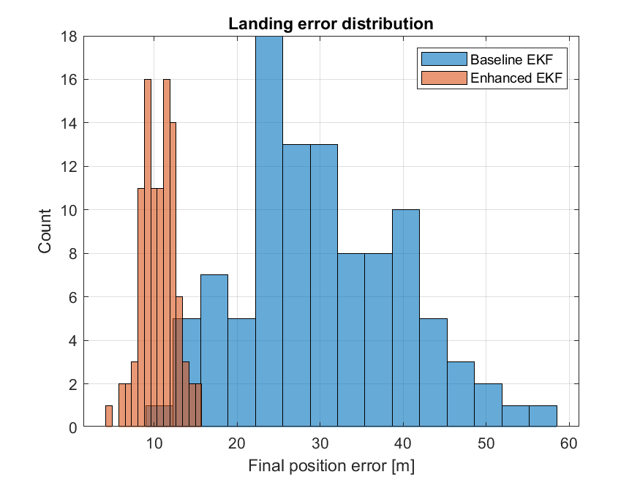
Figure 1: Final Position Estimation Error Distribution
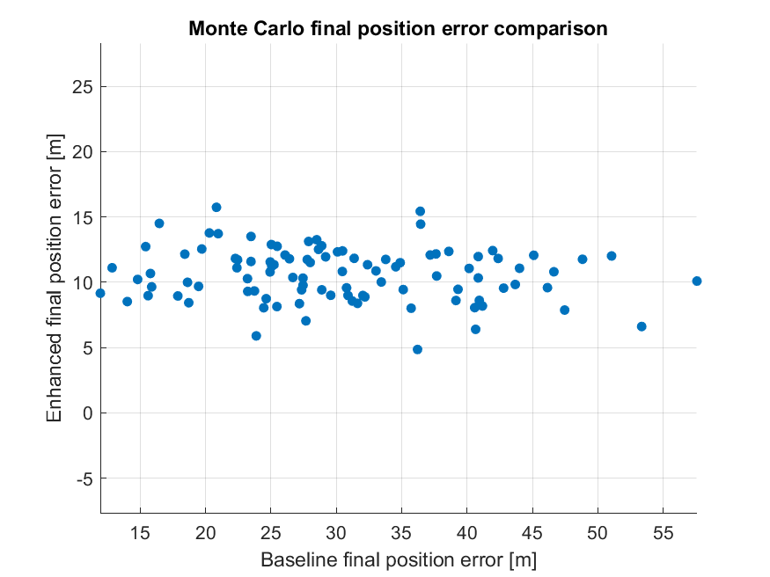

Figure 2: Monte Carlo final position error comparison

Figure 1 compares the final position estimation errors obtained from the 100 Monte Carlo trials. The baseline EKF has a wider distribution, with errors spread across a larger range. The enhanced EKF, on the other hand, has most of its errors concentrated between approximately 8 m and 15 m. This shows that the enhanced filter achieved lower errors in most of the simulation trials.
Figure 2 shows the final position error obtained from each trial for both filters. Each point represents one Monte Carlo simulation. In most cases, the enhanced EKF has a lower error than the baseline EKF. This can be seen from the position of the points, which are all below the line where both filters would have the same error.

7.2 Position Estimation Error and Filter Uncertainty

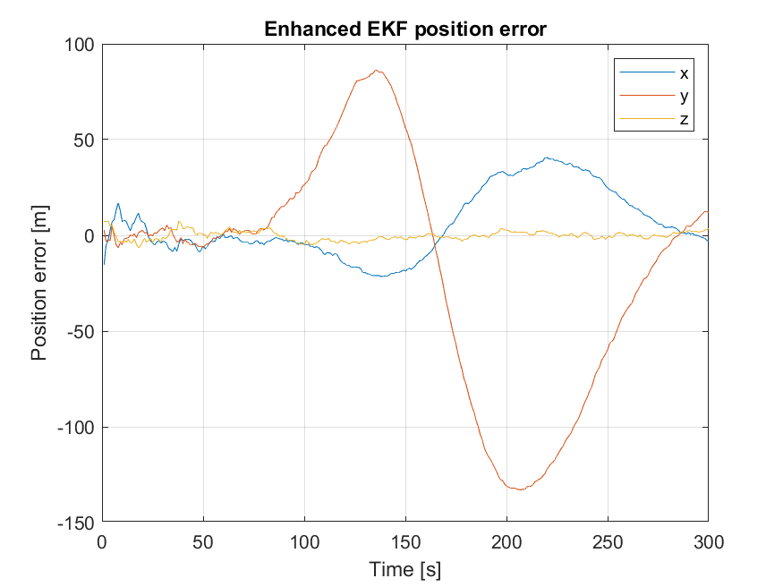
Figure 3: Enhanced EKF position error over time
Figure 3 shows how the position estimation error changes during the 300 second simulation. The three components do not follow the same pattern. The X-axis error changes over time but remains within a relatively smaller range. The Y-axis error shows much larger variations, reaching approximately -135 m before gradually recovering towards the end of the simulation. The Z-axis error remains close to zero throughout most of the simulation.

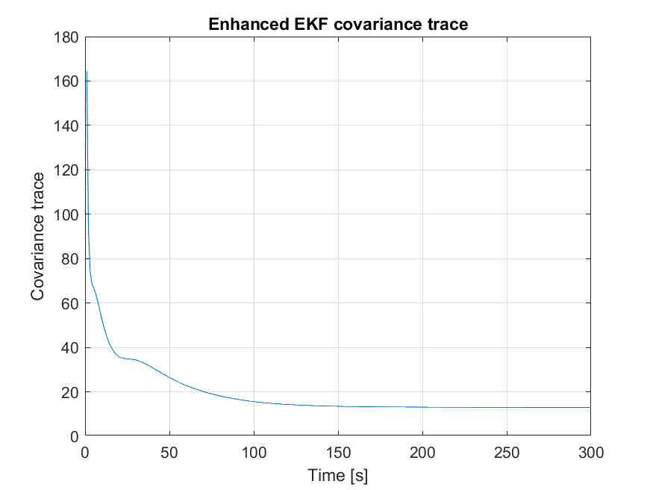
Figure 4: Enhanced EKF Covariance Trace

Figure 4 shows the change in the enhanced EKF covariance trace over time. At the beginning of the simulation, the value decreases rapidly. After that, the decrease becomes more gradual, and the curve starts to level off at around 150 seconds. This shows how the filter's estimated uncertainty changes as the simulation progresses.

7.3 TRN Confidence
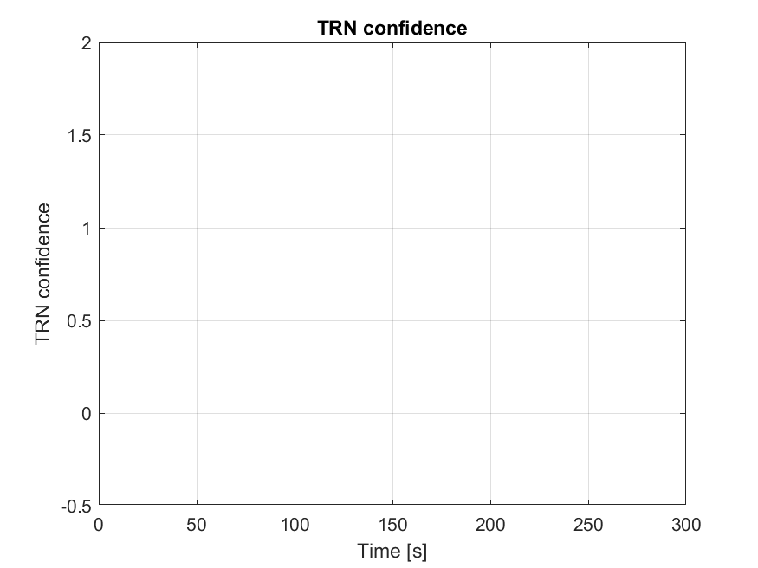
Figure 5: TRN Confidence Over Time
Figure 5 shows the TRN confidence value during the simulation. The value remains constant at approximately 0.68 throughout the 300 seconds. This means that there was no change in the confidence level during this particular run. As a result, the plot shows the confidence value used in the simulation, but does not show how changing dust conditions affect TRN confidence.

7.4 Onboard Clock Offset
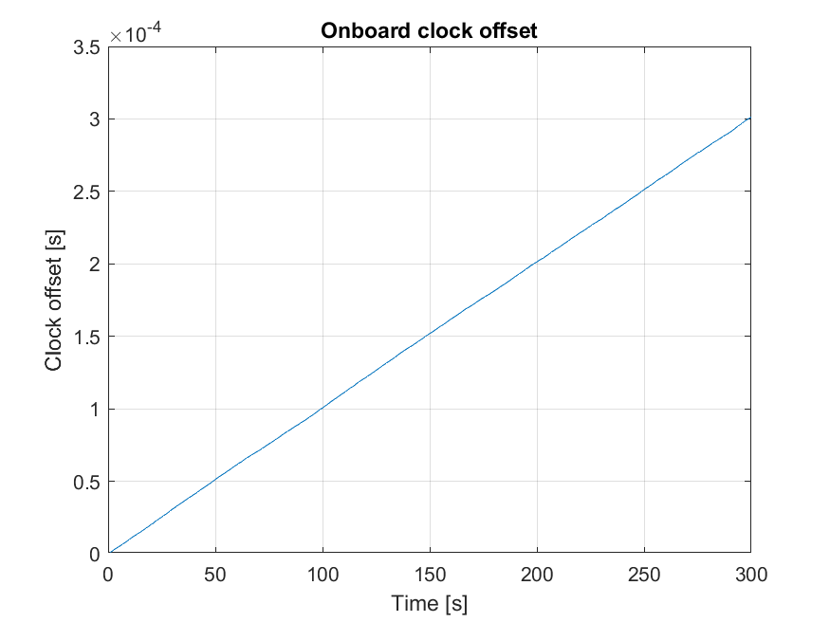
Figure 5. Onboard Clock Offset
Figure 6 presents the onboard clock offset over the 300-second simulation. The offset increases gradually with time, reaching approximately 0.0003 seconds at the end. This represents the difference between the onboard clock and the reference time. The clock behaviour is analysed separately and is not included in the EKF estimation process.

8. Conclusion
This study investigated position estimation during a simplified Mars Entry, Descent, and Landing (EDL) scenario, with a focus on accelerometer errors and uncertainty in Terrain Relative Navigation (TRN) measurements. A MATLAB simulation was developed to compare a baseline Extended Kalman Filter (EKF) with an enhanced version that also estimates accelerometer bias and adjusts TRN measurement uncertainty according to simulated confidence.
The results from the 100 Monte Carlo trials showed that the enhanced EKF achieved a lower mean final position estimation error than the baseline filter. The simulation also included separate models of TRN confidence and onboard clock offset, allowing these aspects to be examined alongside the navigation-filter comparison.
Although the results show an improvement in position estimation with the enhanced configuration, the study represents a simplified simulation and does not cover a complete Mars landing navigation system.

8.1 Key Contributions
The main contributions of this study are related to the development of the MATLAB simulation and the comparison of the two EKF configurations.
- Development of a simplified Mars EDL simulation: A translational model was implemented in MATLAB, including Mars gravity, atmospheric density variation and aerodynamic drag. This provided the basis for testing the navigation filters.
- Modelling of accelerometer errors: The simulation includes measurement noise, initial bias, bias random walk and occasional stochastic bias changes. These effects were used to examine how accelerometer errors influence position estimation.
- Implementation of an enhanced EKF: In addition to estimating position and velocity, the enhanced filter includes accelerometer bias as part of its state vector. It also adjusts the assumed TRN measurement uncertainty according to the simulated confidence level.
- Comparison through Monte Carlo simulations: Both filters were evaluated over 100 trials. The enhanced EKF achieved a mean final position estimation error of 10.598 m, compared with 30.332 m for the baseline EKF. This represents a reduction of approximately 65.1%.
- Separate evaluation of clock behaviour: A clock model was also simulated to observe the development of clock offset over a 300-second period. This analysis was carried out separately from the EKF comparison.

8.2 Limitations
Although the simulation provided useful results, there are some limitations that should be considered.
- Simplified vehicle dynamics: The vehicle is represented using a translational model with position and velocity states. Attitude dynamics, rotational motion, parachute deployment, powered descent and landing contact are not included. Therefore, the simulation does not represent the complete Mars EDL process.
- Simplified IMU error model: The accelerometer model includes measurement noise, initial bias, bias random walk and stochastic bias changes. However, other possible error sources, such as temperature-dependent effects and radiation-induced degradation, are not considered.
- Simplified TRN model: TRN is represented through simulated measurements and a confidence value that affects measurement uncertainty. Actual terrain images, feature extraction and image matching are not implemented. In addition, the TRN confidence remained constant in the plotted simulation, so the effect of changing dust conditions was not demonstrated in that run.
- Separate clock simulation: Clock drift and jitter are simulated independently from the navigation filters. Their effects on sensor timestamps and position estimation are therefore not evaluated.
- Scope of the filter comparison: The enhanced EKF combines accelerometer bias estimation with adaptive TRN measurement weighting. Since both features are introduced together, the current results do not show the individual contribution of each one to the improvement in estimation accuracy.
- Simulation-based evaluation: The results are based on MATLAB simulations and 100 Monte Carlo trials. No hardware-in-the-loop testing or validation using real Mars EDL sensor data was performed. The results should therefore be understood within the assumptions of the simulation.

8.3 Future Work
There are several aspects of the current simulation that could be improved in future work.
- More complete vehicle dynamics: The translational model could be extended to include attitude dynamics, rotational motion and additional stages of the EDL process, such as parachute deployment and powered descent.
- More detailed IMU error modelling: Additional error sources, including temperature-dependent bias changes and scale-factor errors, could be introduced to make the accelerometer model more representative of real sensor behaviour.
- Improvement of the TRN model: Future work could include actual terrain images and image-processing methods for feature extraction and matching. The dust model could also be improved to produce time-varying changes in TRN confidence and measurement quality.
- Integration of clock errors into the navigation filter: Clock drift and jitter could be included in the EKF model to investigate how timing errors affect sensor measurements and position estimation. Possible clock correction methods could also be tested.
- Further evaluation of the enhanced EKF: Additional simulations could be carried out to study the individual effects of accelerometer bias estimation and adaptive TRN measurement weighting. This would help identify how much each feature contributes to the reduction in estimation error.
- Validation with more realistic data: The simulation could be tested using real sensor measurements or hardware-in-the-loop experiments. This would provide a better understanding of how the proposed approach performs beyond the simulated environment.

References
- Berkowitz, R. (2021, July 2). Ion clock makes maiden space voyage. Physics, 14, 99. https://physics.aps.org/articles/v14/99
- Cofield, C. (2021, June 30). Deep Space Atomic Clock moves toward increased spacecraft autonomy. NASA Jet Propulsion Laboratory. https://www.nasa.gov/centers-and-facilities/jpl/deep-space-atomic-clock-moves-toward-increased-spacecraft-autonomy/
- Greicius, A. (2019, June 14). How an atomic clock will get humans to Mars on time. NASA. https://www.nasa.gov/missions/tech-demonstration/deep-space-atomic-clock/how-an-atomic-clock-will-get-humans-to-mars-on-time/
- Groves, P. D. (2013). Principles of GNSS, inertial, and multisensor integrated navigation systems (2nd ed.). Artech House.
- Johnson, A. E. (2020). Terrain relative navigation: Landing between the hazards. NASA Science. https://science.nasa.gov/science-research/science-enabling-technology/technology-highlights/terrain-relative-navigation-landing-between-the-hazards/
- Mendeck, G. F., & McGrew, L. C. (2013). Post-flight EDL entry guidance performance of the 2011 Mars Science Laboratory mission (AAS 13-419; JSC-CN-22651). NASA Johnson Space Center. https://ntrs.nasa.gov/citations/20130009144
- National Aeronautics and Space Administration. (2024). Mars entry, descent, and landing challenges for human missions. 2024 Moon to Mars Architecture Concept Review. https://www.nasa.gov/wp-content/uploads/2024/12/acr24-mars-edl-challenges.pdf
- Way, D. W., Davis, J. L., & Shidner, J. D. (2013). Assessment of the Mars Science Laboratory entry, descent, and landing simulation (AAS 13-420). NASA Langley Research Center. https://ntrs.nasa.gov/api/citations/20130010129/downloads/20130010129.pdf
- Villar, G., Mischna, M., Kass, D., & Karlgaard, C. D. (2022). Post-flight analysis of atmospheric properties from Mars 2020 entry, descent, and landing. NASA Jet Propulsion Laboratory. https://ntrs.nasa.gov/citations/20230005743

